ASSINGMENT – 36

Table creation:

CREATE TABLE EMP_details (

employee_id NUMBER PRIMARY KEY,

employee_name VARCHAR2(50));

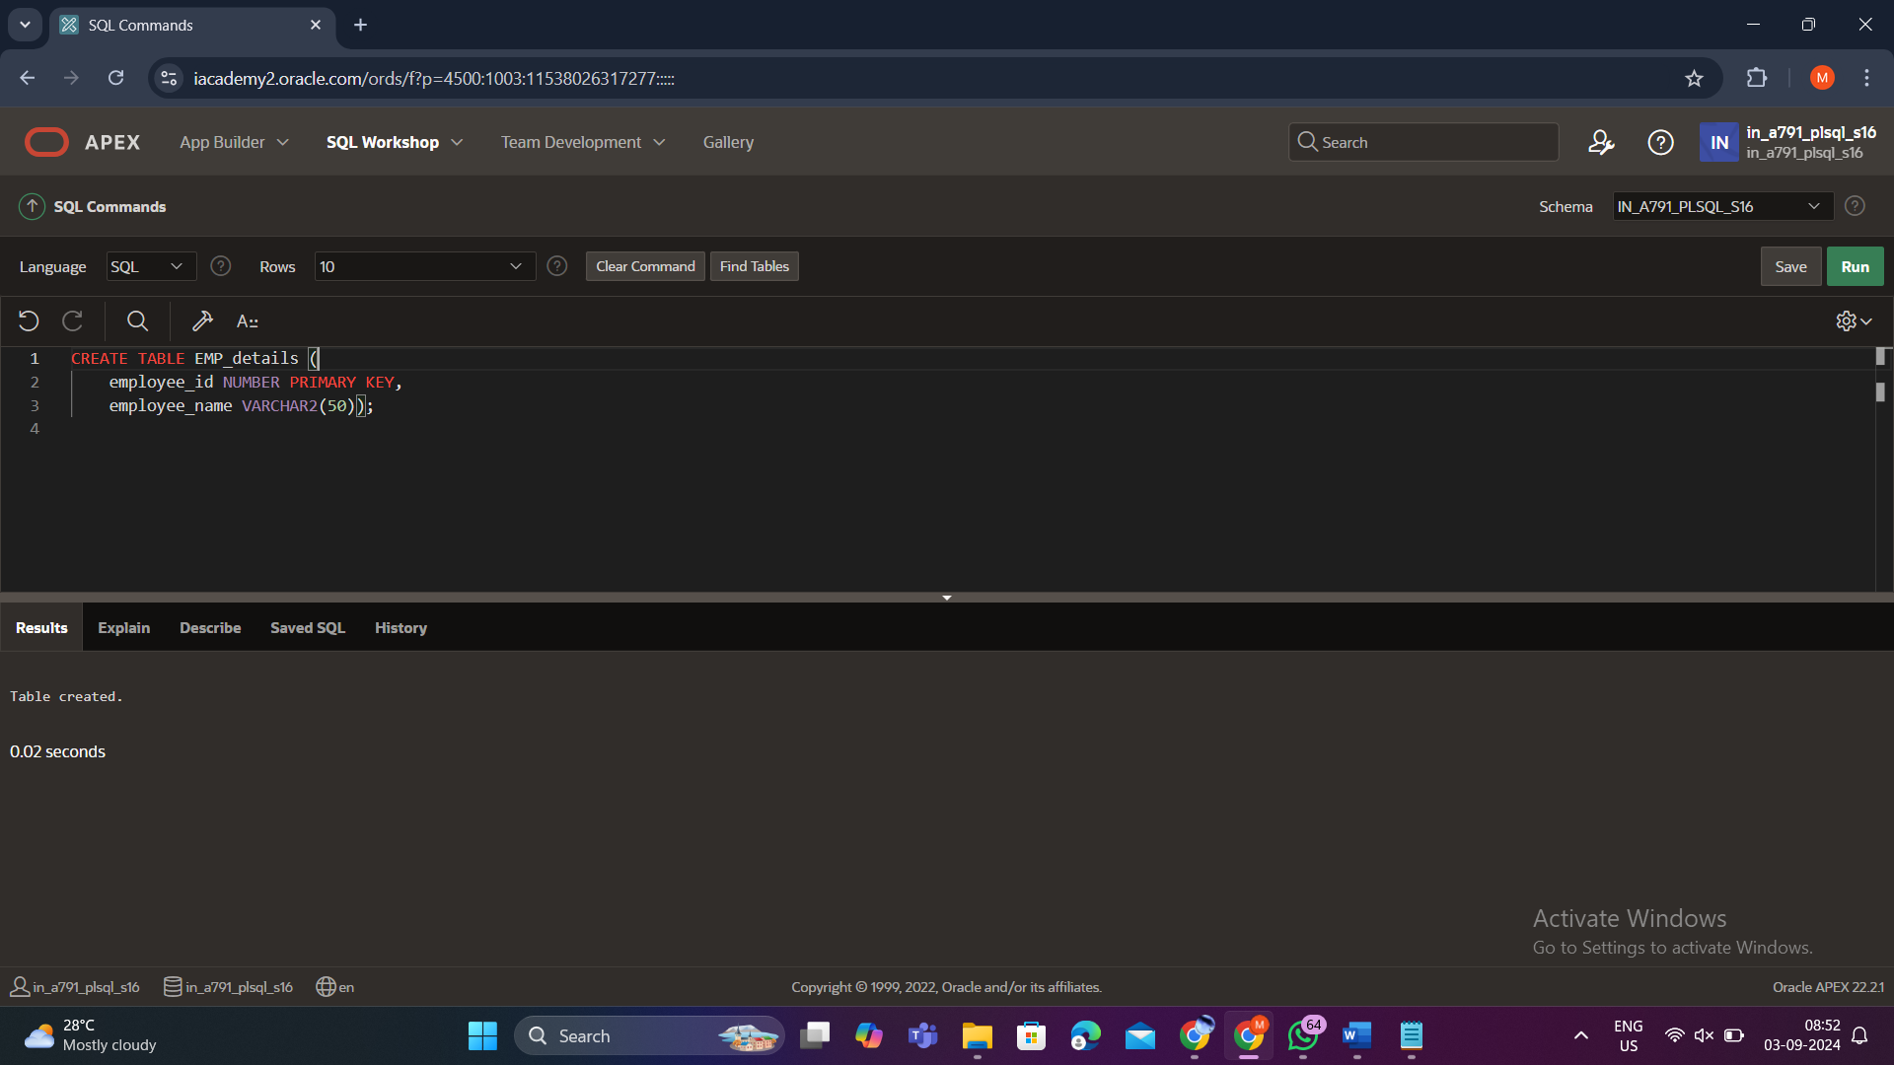

Procedure Creation:

CREATE OR REPLACE PROCEDURE add_row(

p_table_name VARCHAR2,

p_id NUMBER,

p_name VARCHAR2

) IS

BEGIN

EXECUTE IMMEDIATE

'INSERT INTO ' || p_table_name ||

' (employee_id, employee_name) VALUES (' || p_id || ', ''' || p_name || ''')';

END;

/

BEGIN

add_row('EMP_details', 250, 'Chang');

END;

/

